SPECIFICATION LEX1483

R E V： A
TYPE： SPS 85W SERIES

SPEC： 14.5V—18.5V

1. ElECTRICAL
  - Input Characteristics:

1.1.1 Rated Voltage
It is normal for 100-240Vac input AC voltage

1.1.2 Input Voltage range
The adapter shall operate from 90Vac to 264Vac and no range switching is necessary or possible.

1.1.3 Rated Frequency
The frequency of adapter was changed when it work in different model.

1.1.4 Frequency range
The adapter shall operate with an input frequency from 47Hz to 63Hz

1.1.5 Steady AC Current
Maximum steady state input current is less than 1.8A rms at 100Vac input and maximum load.

1.1.6 Inrush Current
Maximum inrush current shall be less than 40A at 240Vac input.

1.1.7 Power Efficiency
80% Min. measured at 100Vac input voltage, maximum load and include the DC cable loss.
  - Output Characteristics

1.2.1 Rated Voltage
The rated output voltage is specified from 14.5V to 18.5V

1.2.2 Voltage Range
The output voltage will be performed ±0.35V

1.2.3 Rated Power
This adapter is capable to support 85Watts continuously at all specified conditions.

1.2.4 Current
Maximum current is 5.8A when the output voltage is 14.5V.
Maximum current is 4.6A when the output voltage is 18.5V.

1.2.5 Output Ripple and Noise
Output ripple voltage is 200mV peak to Peak or less.
(Ripple voltage is specified in working cycle of this supply ).
Output noise voltage is 200mV peak to Peak or less.
(Noise voltage is specified in the switching noise of this supply ).
Measured methods:
T1. Performed by 20MHz bandwidth in oscilloscope.
T2. Applied 0.1uF ceramic capacitor and 10uF electrolytic capacitor across output
Connector terminals.
T3. Measured at the end of DC cable.

1.2.6 Stability
The adapter is unconditionally stable while operating within its normal operating specification.

1.2.7 Protection.

1.2.7.1 Short Circuit
The adapter is protected when a short happened between the output terminals and shall not result in a fire hazard, any damage to this adapter and will be normal operation automatically while the short is removed.

1.2.7.2 Over current protection
The power supply shall be protected when output current over each peak current For example when the output voltage is 18.5V,the power supply shall be protect when the output current over 7A.
      - Over voltage protection
The power supply shall be protected when output voltage over 33V.

2. Environmental

2.1 Temperature

2.1.1 Operating
The adapter is capable to operate from 0 to 45℃.

2.1.2 Non-Operating
The adapter is capable to operate from -20 to 80℃.

2.2 Humidity

2.2.1 Operating
The adapter is capable to operate from 10 to 90%RH

2.2.2 NON-Operating
The adapter is capable to operate from 5 to 90%RH

2.3 Cooling
The adapter is convention cooled only

2.4 Altitude

2.4.1 Operating
The adapter is capable to operate at 10,000 feet above sea level

2.4.2 Non-Operating
The adapter is capable be stored at 33,000 feet above sea level

2.5 Vibration

2.5.1 Operating
AC input voltage: Rated voltage
DC output load: Maximum
Acceleration: 1.0G
Orientation: Three mutually perpendicular axes X,Y,Z.
Frequency 10 to 300Hz at 0.3 decades/min.
Duration: 30 minutes per axis,15 minutes at a constant acceleration of 2.0G for resonant frequencies

2.5.2 Non-Operating(constant vibration)
Acceleration: 3.0G
Orientation: Three mutually perpendicular axes X,Y,Z.
Frequency 10 to 300Hz at 0.3 decades/min.
Duration: 30 minutes per axe, 15 minutes at a constant acceleration of 3.0G for resonant frequencies.
After the above testing, the adapter have to work normally and no any damage.

2.6 Drop(Non-operating)
The adapter is capable to survive a drop from 100cm height to rigid surface of concrete.
It shall be dropped once for each one of its six without any packaging after the completion of the drop test the adapter have to meet function within specifications.
No structural damage is allowed. Cosmetic damages such as small dents and scratches are acceptable.

2.7 Dielectric Withstand Voltage(HI-POT)
100% of line products of this adapter shall be applied 3000VAC or 4200VDC for a minimum of 1 minute between AC input terminals and output terminals. The cut off current is specified as 10mA.

2.8 Leakage Current
The measured reading is less than 0.10mA at 264 V AC,50Hz.

2.9 Insulation Resistance
The resistance is more than 100MΩ at apply 500 VDC between input terminals and Case.
The resistance is more than 100MΩ at apply 500 VDC between input terminals and output terminals.

3. Mechanical

3.1 Adapter drawing
The external dimensions of adapter is 101.00mm(Length)×69.00mm(Width)×29.00mm(Height)

3.2 Material
The case material is PC.Class 94V-0.

3.3 Color
The color is specified in WHITE.

3.4 DC Cord

3.4.1 Output cord : 8A WHITE 2.0M±20mm

3.4.2 Output plug :

3.4.3 Output polarity:

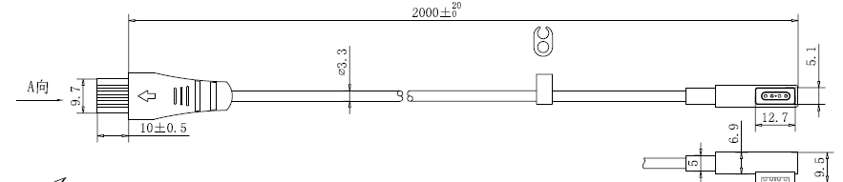

Outline Dimension(unit:mm)

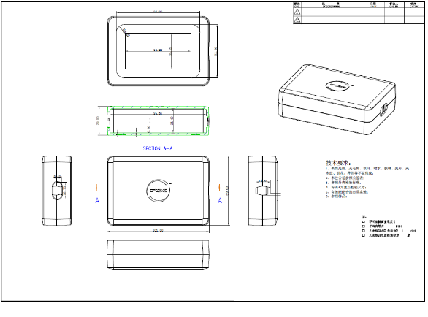

Testing

Model No.: SPS 85W SERIES AC input range: 100Vac-240Vac
NO. | No load voltage (VDC) | Rated voltage I=5.66A (VDC) | Ripple noise  (mV) | Efficiency | Over current (A) | Short circuit | Leakage current test | Insulation resistance test | Hi pot test | Over Temperature
SPEC | 18.5V±0.5 | 18.5±0.5 | 300Mv Max | 80% Min | 7A Max | No Damage | ILK＜0.10mA | 500VDC 100MΩ Min | PRI-SEC:3.0KV AC  PRI-CASE:3.0KV AC 10MA 1Min | 70℃±3  No Damage
1 | 18.8 | 18.1 | OK | 80.3% | 6.2 | OK | OK | OK | OK | OK
2 | 18.7 | 18.2 | OK | 80.3% | 6.1 | OK | OK | OK | OK | OK
3 | 18.8 | 18.1 | OK | 80.4% | 6.2 | OK | OK | OK | OK | OK
4 | 18.8 | 18.2 | OK | 80.3% | 6.1 | OK | OK | OK | OK | OK
5 | 18.8 | 18.1 | OK | 80.5% | 6.2 | OK | OK | OK | OK | OK
6
7
8
9
10

