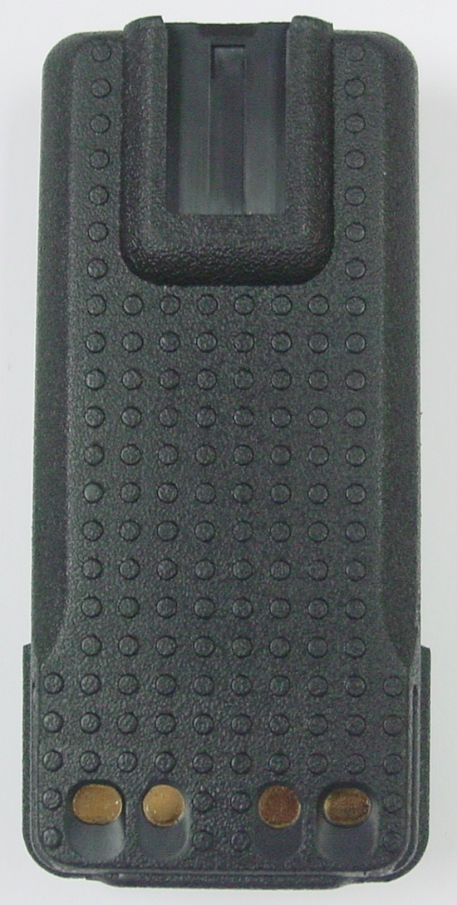
SPECIFICATION FOR RML0631

For use on: Motorola radios
Models: XPR3300, DP2000/4000
Size : L 114.5 x W 55 x D 27 mm
Voltage: 7.4V
Rated capacity: 2100mAH
Cells Brand : Sanyo UR18650AY
Plastic case : ABS
L
Charge rate: Rapid
Charge time: 1 hour +/- 10%
Assembled in: Hong Kong
Welding : Pure Nickel Tabs W/ Spot Welder
Sealing : Ultrasonic
Flexible PCB: YES

The RML0631 is guaranteed to meet or exceed the original manufacturers specifications for proper fit and functionality in the OEM’s radio and charger.

